Section 23 Backend Web Dev

Severs Applications and DB – back end

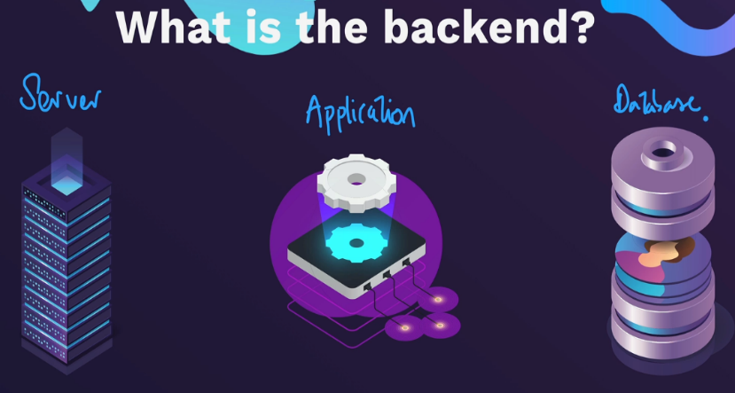

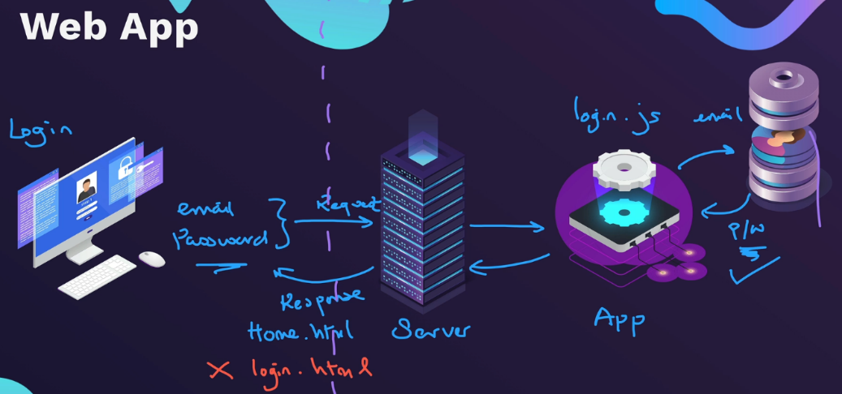

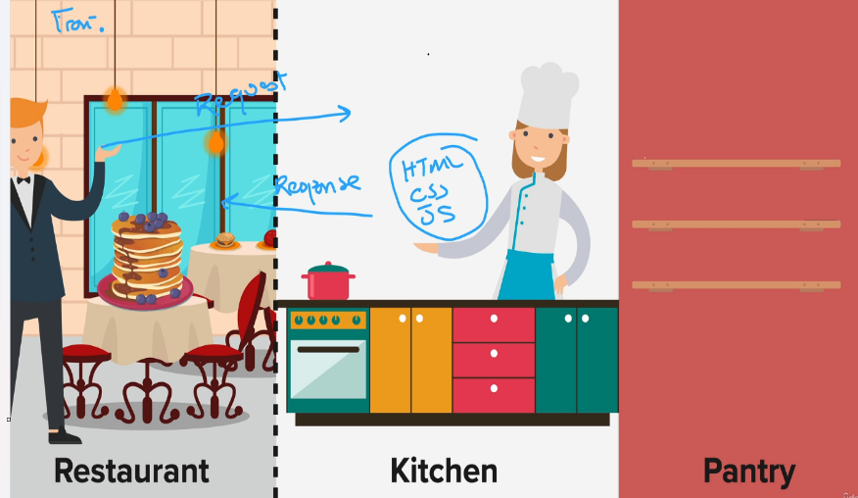

Backend tooling and technologies

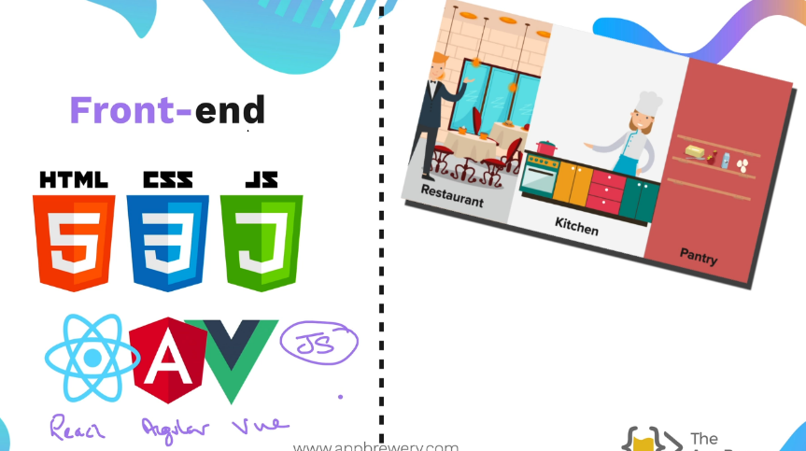

Backend

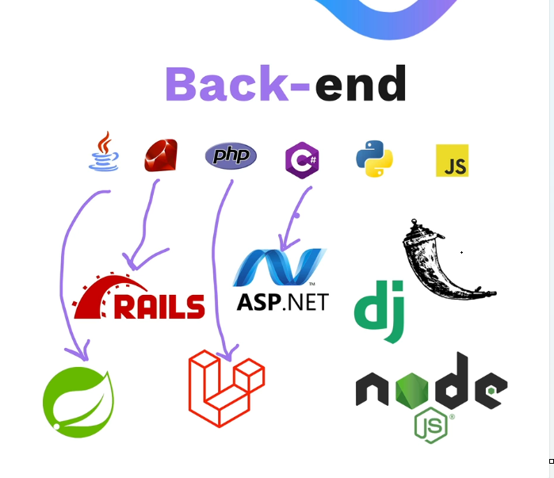

Node JS



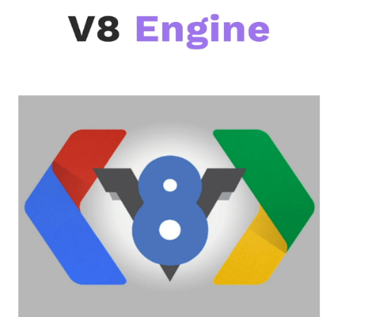

\

Node REPL



To open the node REPL type node

Using native node modules – starting toolset , built in

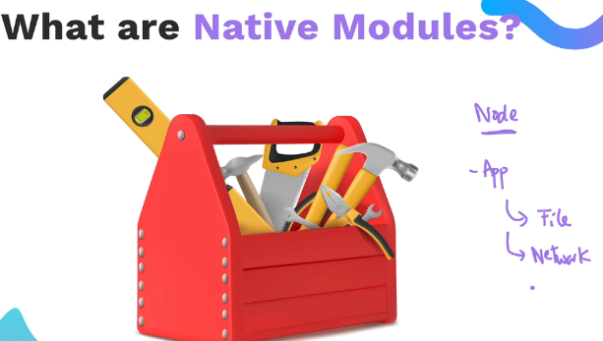

https://nodejs.org/docs/latest-v18.x/api/index.html

Common JS vs EMS syntax

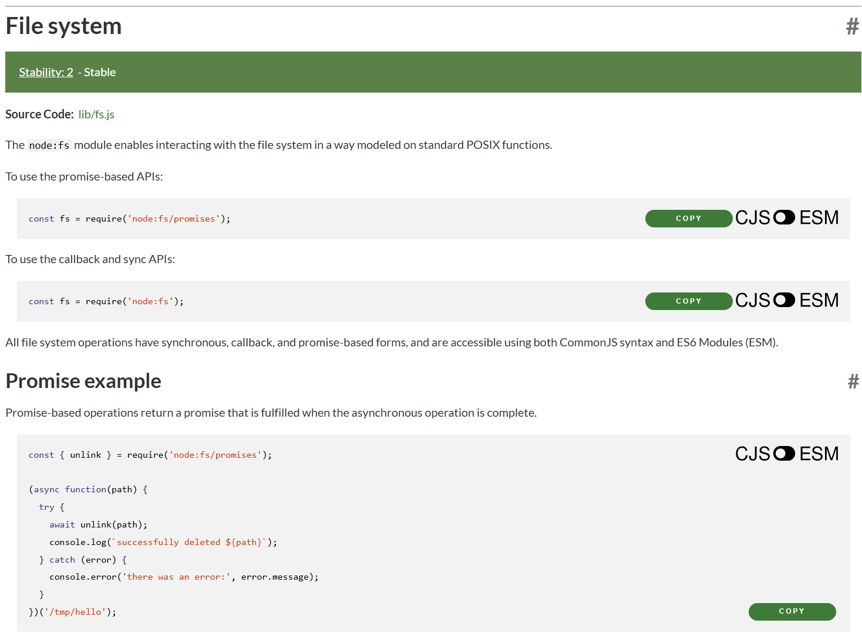

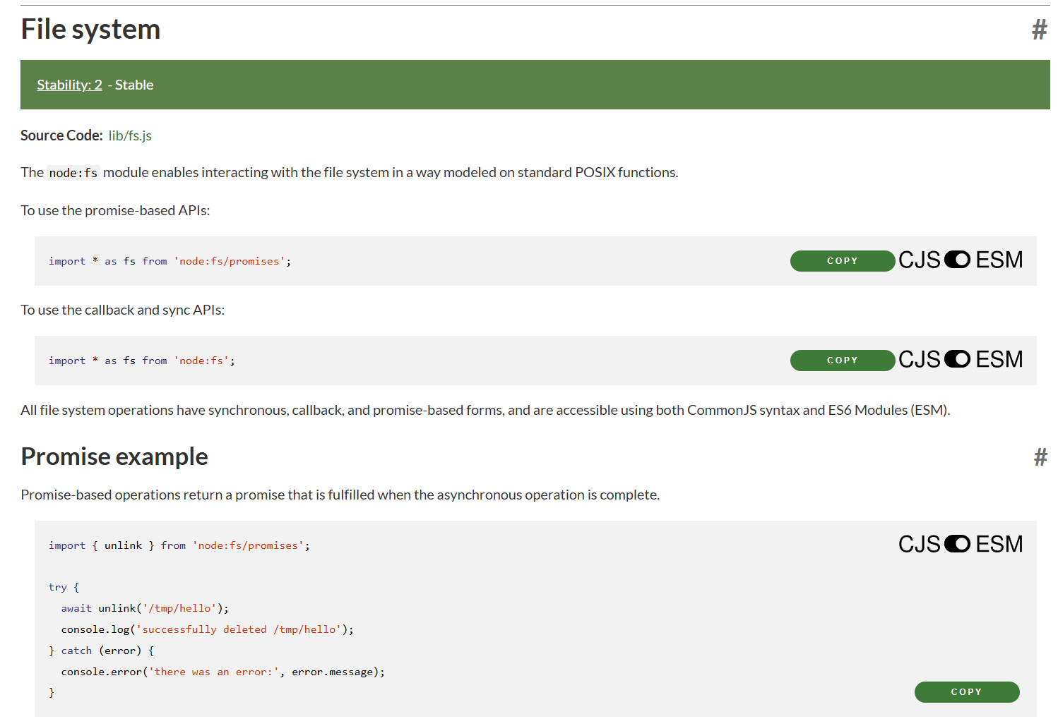

Node package manager – npm collection of prebuilt node packages by GitHub – community tool library

Node comes with npm so can use npm init out of the box

Node now uses ESM, so use it instead of common js (CJS)

Update “type” to module

Use:

1. import { randomSuperhero } from "superheroes";
2. const name = randomSuperhero();

Instead of:

1. import superheroes from "superheroes";
2. const name = superheroes.random();

npm init creates package.json

<https://www.npmjs.com/package/sillyname>

Generate a QR Code project - user scans to direct them to a URL

Get input from user who types into terminal , generate qr code and save it locally, create a text file that contains what the user typed in using fs module

<https://www.npmjs.com/package/inquirer>

npm i inquirer

generate qr image

<https://www.npmjs.com/package/qr-image>

npm i qr-image

Restart here

<https://www.udemy.com/course/the-complete-web-development-bootcamp/learn/lecture/38126546#questions/12105158>